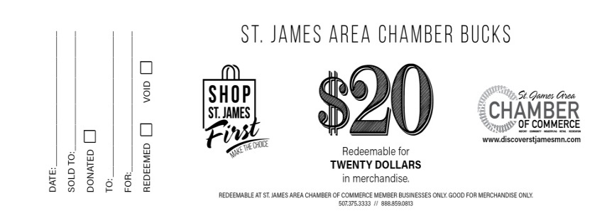
SPEND YOUR CHAMBER BUCKS AT THE FOLLOWING LOCATIONS!
Anytime Fitness
American Legion
Arcane Crafts
Bailey’s Restaurant and Bar
Brian McCabe Agency
C & B Operations LLC
Collage St. James
Creative Touch
Edward Jones
Encore Coffee Café
Englund's St. James Cleaners
Eye Care Center of St. James
Fleet & Farm Supply/ACE Hardware
Fraternal Order of Eagles
Gem Den, LLC
Golf-Mor, LLC
Harder Agency
Hometown Family Restaurant
ICS Storage Systems, LLC
Jake's Pizza
Johnson Meat Market
Johns Northstar
Kelsey Osborne, LLC
KNUJ Radio
Kroubetz Lakeside Campers
Kuehl's Electric, Inc.
Lewis Family Drug
Lord’s and Ladies
Massage by Jennifer
McDonald’s
NAPA Auto & Truck Parts of St. James
Ness Agency
Plaza Jalisco
Preferred Printing Company
Princess Theater
Resilient Nutrition
Schmidt's Bakery
Sharpline
St. James Electric
St. James Family Dentistry, P.C.
St. James Golf Course/Rivers Edge Bar and Grill
St. James Liquor
St. James Publishing
St. James Sertoma
St. James Veterans of Foreign Wars
Steinle Law PLLC
Subway of St. James
Super 8 of St. James
Super Fair Foods
True Value/Radio Shack/Verizon
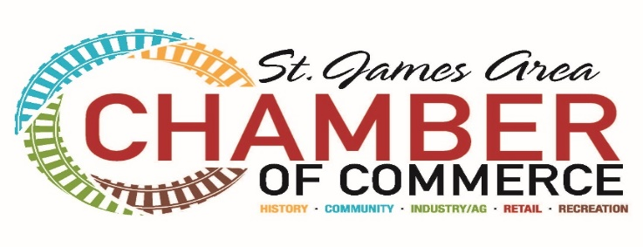
Merchants are not required to give cash back if the purchase is less these than the amount of the chamber bucks 2/23

